ACIDS AND BASES A-LEVEL WORKSHOP QUESTIONS

SIMPLER QUESTIONS AND CALCULATIONS

1. 2014 Old Unit 1. Qn. 10

Nitrogen (IV) oxide reacts with water. H₂O + 2NO₂ → HNO₂ + HNO₃. Both nitric(III) acid, HNO₂, and nitric(V) acid, HNO₃, are described as being acids.

(i) Define an acid.

(ii) Write an equation to show nitric(III) acid behaving as an acid.

(iii) When concentrated nitric(V) acid is mixed with concentrated sulfuric acid the reaction shown occurs. HNO₃ + H₂SO₄ → H₂NO₃⁺ + HSO₄ – . Explain this reaction in terms of acid-base behaviour.

2. 2014 Old Unit 1. Qn. 12. Hydromagnesite is a mixture of magnesium carbonate and soluble impurities. A student crushed some hydromagnesite and added a sample of mass 0.889 g to excess dilute hydrochloric acid so that the magnesium carbonate component reacted fully.

(a) Explain why the rock was crushed before being added to the acid.

(b) Write the equation for the reaction between magnesium carbonate and dilute hydrochloric acid.

3. 2014 Old Unit 5. Qn. 1 Ammonium salts are very important chemicals as they are used as a nitrogen source in fertilisers.

(a) When cold aqueous sodium hydroxide is added to an ammonium salt, the following
equilibrium exists: NH₄⁺(aq) + OH⁻(aq) ⇌ NH₃(aq) + H₂O(I)

Identify the two acid-base conjugate pairs in the equilibrium.

4. 2019 Unit 3. Qn. 3 Write the expression for the ionic product of water, Kw.

5. 2019 Unit 3. Qn. 10c(ii) Ethanoic acid is a weak acid with Ka = 1.76 × 10^{–5} mol dm^{–3}. Calculate the pH of an aqueous solution of ethanoic acid with a concentration of 0.220 mol dm^{–3}.

6. 2018 Unit 3. Qn. 7. When a solution containing the weak base ammonia is neutralised using the strong acid sulfuric acid, a solution of ammonium sulfate is formed. Suggest a pH for this solution, giving a reason for your answer.

7. 2018 Unit 1. Qn. 9f. Sulfuric acid and hydrochloric acid are strong acids. (i) Calculate the pH of a solution of 0.010 mol dm^{–3} sulfuric acid, H₂SO₄.
BUFFERS AND TITRATIONS

8. 2015 Old Unit 5. Qn. 4

(f) Heating ethanedioic acid in glycerol produces methanoic acid, HCOOH.

(i) Write the expression for the acid dissociation constant, K_{a}, for methanoic acid.

(ii) The value of K_{a} for methanoic acid is 1.8 × 10⁻⁴ mol dm⁻³. Calculate the pH of a solution of methanoic acid of concentration 0.2 mol dm⁻³.

(iii) A mixture of methanoic acid and sodium methanoate can be used as a buffer solution. State what is meant by a buffer solution and explain how a mixture of methanoic acid and sodium methanoate acts as a buffer.

9. 2016 Old Unit 1. Qn. 8. A student was given an aqueous solution of iodic(V) acid, HIO₃, and was asked to find its concentration by titration with sodium hydroxide solution.
NaOH + HIO₃ → NaIO₃ + H₂O
He rinsed the burette with water and then filled it with the iodic(V) acid solution. 25.0 cm³ of sodium hydroxide solution of concentration 0.125 mol dm⁻³ were used for each titration against the aqueous iodic(V) acid. The following results were obtained.

Titration | 1 | 2 | 3 | 4 | 5
Volume of iodic(V) acid solution used / cm³ | 19.20 | 18.60 | 18.70 | 18.55 | 18.55

(i) Sodium hydroxide is described as a base. State what is meant by the term base.

(ii) The teacher said that the result of titration 1 was too high. State one reason why a
fault in the practical method could explain this result.

(iii) Use the results from titrations 2 to 5 to calculate the mean volume of iodic(V) acid
solution and hence the concentration of the acid in mol dm⁻³.

10. 2017 Unit 1. Qn. 7b. 25.0 cm³ samples of a sodium carbonate solution were titrated against the hydrochloric acid. These were the results.

Titration | 1 | 2 | 3 | 4
Final reading / cm³ | 26.50 | 26.80 | 26.20 | 26.55
Initial reading / cm³ | 0.40 | 0.15 | 0.00 | 0.25
Titre / cm³ | 26.10 | 26.65 | 26.20 | 26.30

(i) Calculate the mean titre that should be used to determine the concentration of the
hydrochloric acid.

(ii) The burette used in the titrations has an uncertainty for each reading of ±0.05 cm³. Estimate the maximum percentage error in the titre in titration 4. Show your working.

(iii) Apart from errors in reading the burette, suggest one reason why incorrect titres
may have been obtained when carrying out the titrations. Explain the effect of this
error on the value of the titre obtained.

11. 2019 Unit 1. Qn. 11

A student was asked to find the percentage of calcium carbonate in a sample of chalk. He used the following chemicals.
• Three chalk pieces of identical composition and mass 2.54g
• Hydrochloric acid solution of concentration 1.00 mol dm⁻³
• Sodium hydroxide solution of concentration 0.100 mol dm⁻³

Method
• Use a burette to measure 50.00cm³ of hydrochloric acid (an excess) into a 100cm³
beaker.
• Put a piece of chalk into the beaker and leave until the reaction finishes.
• Filter the solution into a conical flask to remove any solid impurities.
• Add a few drops of indicator to the solution in the conical flask and titrate against the
sodium hydroxide solution.
• Repeat the procedure using the other chalk pieces and calculate a mean titre.
• Use the mean titre to calculate the percentage of calcium carbonate in the chalk sample.

Results
Mass of each chalk piece = 2.54g

Titration | 1 | 2 | 3
Final reading / cm³ | 16.80 | 33.05 | 16.70
Initial reading / cm³ | 0.20 | 16.80 | 0.35
Titre / cm³ | 16.60 | 16.25 | 16.35
Mean titre = 16.40cm³

(a) State how the student would know that the reaction between the chalk and acid had
finished.

(b) Suggest and explain two improvements to the student’s method.

(c) The equation for the reaction between calcium carbonate and hydrochloric acid is as
follows.
CaCO₃(s) + 2HCl(aq) → CaCl₂(aq) + H₂O(l) + CO₂(g)

Use this and the student’s results, including the mean titre of 16.40cm³, to calculate the
percentage of calcium carbonate in the chalk sample.
12. 2016 Unit 5. Qn. 2. Acids can be considered to be strong or weak and concentrated or dilute.

(a) For an aqueous solution of an acid, explain the difference between the meaning of the
terms weak acid and dilute acid.

(b) The grids opposite show titration curves for the addition of aqueous sodium hydroxide
solution to 25.0 cm³ of aqueous acid. From the list below, choose which acids were used to give curves A and B giving reasons for your answer
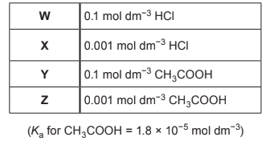

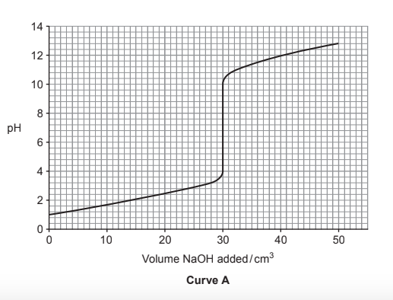
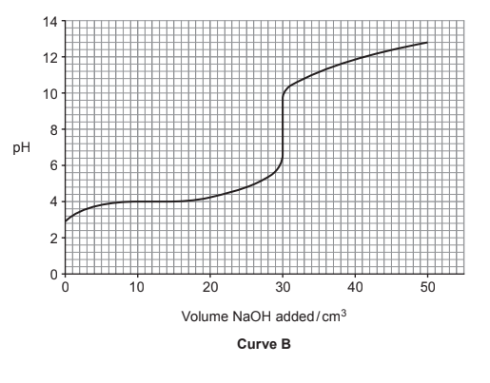
i. State, giving a reason, which of the following indicators would be most suitable for titration B.
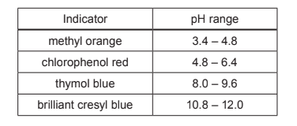
ii. Calculate the concentration of the aqueous sodium hydroxide solution used in titration A.

(c) Aqueous ammonia reacts with hydrochloric acid to form the salt ammonium chloride, NH₄Cl. Give a reason why the pH value for a solution of NH₄Cl is less than 7.

13. 2017 Unit 3. Qu 7a.

(a) Ammonia is an example of a weak base. Describe what is meant by the term weak base.

(b) A mixture of ammonia and ammonium chloride in aqueous solution can be used as a
basic buffer solution. Explain what is meant by a buffer solution and how this mixture can
act as a buffer solution.

(c) The pH curve for titration of a solution of ammonia against hydrochloric acid of an equal
concentration is given below.
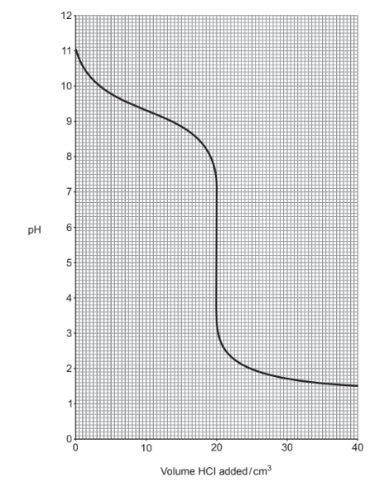
(i) Calculate K_{a} for the ammonium ion.
(ii) Select an appropriate indicator for this titration from the list below, giving a reason for your answer.

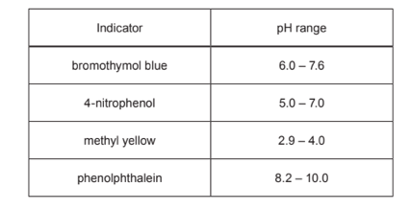
14. 2019 Unit 3. Qn. 11. (b) Oxalic acid solutions may be analysed using acid-base titrations. The simplified pH curve for the titration of a solution of oxalic acid against sodium hydroxide is given below.
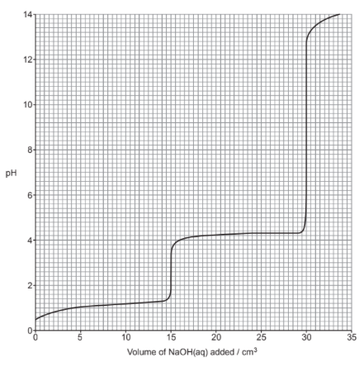
Four students undertook the titration in different ways:

• Alice used a pH probe to measure the pH after addition of each portion of sodium hydroxide solution
• Brychan used the indicator phenolphthalein in his titration; phenolphthalein has a pH range of 8.2 to 10.0
• Carys used the indicator methyl orange in her titration; methyl orange has a pH range of 3.2 to 4.4
• David used the indicator cresol red in his titration; cresol red has a pH range of 1.8 to 2.8

(b) State and explain which, if any, of the methods chosen will allow the students to find valid data to calculate the concentration of oxalic acid. Briefly explain why oxalic acid has a pH curve of this shape.

TOUGHER QUESTIONS AND CALCULATIONS

15. 2014 Old Unit 5. Qn. 2a) Write an expression for the ionic product of water, K_{w}, giving its units, if any.

(bi) The value for K_{w} at 298 K is 1.0 × 10⁻¹⁴. Explain why the pH of pure water at this temperature has a value of 7.

(ii) Calculate the pH of the final solution if 10cm³ of 0.10 mol dm⁻³ hydrochloric acid is
added to 990 cm³ of pure water.

(c) Calculate the pH of a solution which is 0.010 mol dm⁻³ with respect to ethanoic acid (K_{a} for ethanoic acid = 1.78 × 10⁻⁵ mol dm⁻³) and 0.020 mol dm⁻³ sodium ethanoate at 298K.

(d) If 10 cm³ of 0.10 mol dm⁻³ hydrochloric acid is added to 990 cm³ of the solution described in (c) the change in pH is only 0.06. Explain why this change in pH is much smaller than that in (b)(ii).

16. 2017 Unit 1. Qn. 8 Sulfur dioxide can react with oxygen and water to form sulfuric acid. Although sulfuric acid is a strong acid, it does not have to be a concentrated acid.

(b) Explain the difference between the terms strong acid and concentrated acid.

(c)i A student was given an aqueous solution of a monoprotic acid HX and was asked to find out if it was a strong or weak acid. 25.0 cm³ of the acid HX required 15.90 cm³ of 0.0125 mol dm⁻³ NaOH solution for complete neutralisation. Calculate the concentration of the acid.

(ii) A teacher measured the pH of the aqueous solution and found it to be 2.10. She told the student that the acid in the solution must be a strong one. Is she correct? Justify your answer.

17. 2018 Unit 3. Qn. 8b) Fluorine can form the weak acid hydrofluoric acid, HF. This acid has a K_{a} value of 7.20 × 10^{–4} mol dm^{–3}.

(i) Write an expression for the K_{a} of hydrofluoric acid.

(ii) Calculate the pH of a solution of hydrofluoric acid of concentration 0.100 mol dm^{–3}.

(iii) The concentration of a solution of hydrofluoric acid can be found by titrating against sodium hydroxide. Not all acid-base indicators would be suitable for this titration. Explain what features would make an indicator suitable for use in a weak acid-strong base titration.

(iv) Addition of 12.5 cm³ of 0.100 mol dm^{–3} sodium hydroxide to 25.0 cm³ of hydrofluoric acid of concentration 0.100 mol dm^{–3} forms a buffer solution.

I. Explain how this buffer solution works.
II. Calculate the pH of this buffer solution.

