ADDITION REACTIONS – A-LEVEL QUESTIONS
SIMPLER QUESTIONS
1. 2018 Unit 2 Qn. 9d. Suggest the type of reaction that occurs between ethyne (C₂H₂) and hydrogen.

2. 2018 Unit 2 Qn. 6. Draw two repeat units for the polymer formed from the monomer pent-2-ene.

3. 2016 New Unit 2 Qn. 3. Draw a section of the addition polymer formed from the monomer below. You should show two repeat units.

CH₃CH(OH)CH=CHCl

4. 2017 Unit 2 Qn. 4 A section of a polymer is shown. Draw the structural formula of the monomer used to make this polymer.

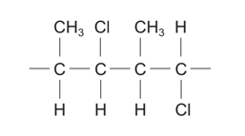

5. 2019 Unit 2 Qn. 5

(a) State the type of polymerisation involved when 2-fluorobut-2-ene, CH₃CF=CHCH₃, forms a polymer.

(b) Draw one repeat unit of the polymer formed when 2-fluorobut-2-ene is polymerised.

6. 2018 Unit 4 Qn. 1

(a) Complete the equation below, which shows the reaction of benzaldehyde with hydrogen cyanide.

(b) Give the formula of the nucleophile that takes part in the reaction shown in part (a).

7. 2014 Unit 4 Qn. 3dii Suggest a displayed formula for the aromatic compound formed when anethole reacts with hydrobromic acid.
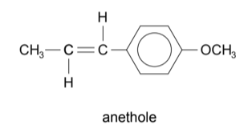
8. 2017 Unit 2 Qn. 10b. When 2-chlorobutane is heated with sodium hydroxide dissolved in ethanol three different organic products are formed.
(i) Draw the displayed formulae of the three products. Name each product.
(ii) Name the type of reaction taking place.

9. 2015 Unit 2 Qn. 11b. Bromoethane can be converted to ethene.
(i) Name the reagent and solvent needed to convert bromoethane to ethene.
(ii) What type of reaction occurs in (b)(i)?
(iii) 2-Bromobutane behaves in a similar way to bromoethane in this reaction. When 2-bromobutane is reacted as described in (b)(i) two alkenes that are structural isomers are formed.
Draw the displayed formulae of these two alkenes.

10. 2016 Old Unit 2 Qn. 8b and c
Ethanol can be produced from many different sources,
(b) In industry, most ethanol is produced from ethene. Give the reagents and conditions for this process.
(c) Ethanol can be produced from chloroethane in a nucleophilic substitution reaction using aqueous sodium hydroxide
(iii) Under different conditions sodium hydroxide can react with chloroethane to produce ethene.
I. Give the conditions needed for this reaction.
II. Classify the mechanism of this reaction

11. 22015 Unit 4 Qn. 3 (h) Ethyne reacts with carbon monoxide in the presence of water to produce propenoic acid.
(i) Give the structure of the repeating unit obtained when propenoic acid is polymerised to give poly(propenoic acid).
(ii) A new method to obtain propenoic acid is by fermentation of a suitable sugar. This method gives 3-hydroxypropanoic acid, which can then be converted to propenoic acid.
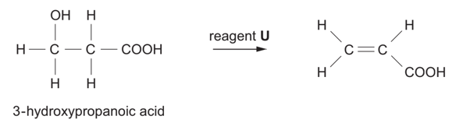
I. Suggest the name of reagent U.
MECHANISMS AND REACTION SCHEMES
12. 2018 Unit 4 Qn. 8dii. The addition of hydrogen bromide to 1,3,3,3-tetrafluoropropene results in two structural isomers, each of molecular formula C₃H₃BrF₄.
I. State the type of mechanism occurring in this reaction.
II. These two compounds are formed in approximately equal amounts in this reaction.
Suggest why this ratio is different to that found in the reactions of other alkenes.
13. 2014 Unit 2 Qn. 11a. Propene reacts with hydrogen bromide to give 2-bromopropane.
(i) Draw the mechanism for this reaction.
(ii) Explain why the product of this reaction is mainly 2-bromopropane rather than 1-bromopropane.
14. 2015 Unit 4 Qn. 3e. Alkynes react with hydrogen bromide by electrophilic addition to give brominated alkenes. By analogy with the reaction of propene with hydrogen bromide, complete the mechanism of the reaction of but-2-yne with hydrogen bromide to give 2-bromobut-2-ene.
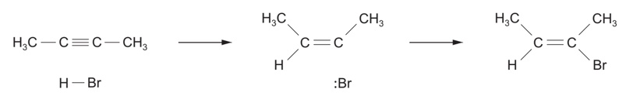
15. 2016 New Unit 2 Qn. 9b All hydrocarbons can be burned but, apart from in combustion reactions, alkenes are more reactive than alkanes. Draw the mechanism for the reaction between propene and bromine. You should show any relevant dipoles, lone pairs of electrons and curly arrows to indicate the movement of pairs of electrons.
16. 2019 Unit 4 Qn. 9biv. Propenal reacts with hydrogen cyanide by a nucleophilic addition reaction. Complete the mechanism for this reaction using curly arrows and partial/complete charges as appropriate.
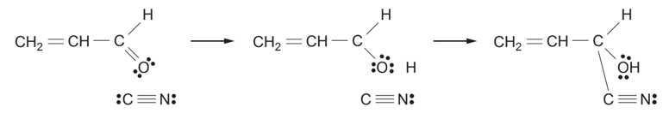
17. 2014 Unit 4 Qn. 4b. A species of millipede can protect itself by producing hydrogen cyanide. This poisonous gas is formed from mandelonitrile by enzyme action.
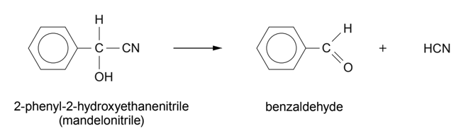
This reaction can be carried out in the reverse direction in the laboratory. Draw the mechanism for the reaction between benzaldehyde and the cyanide ion. State the type of mechanism occurring.

TOUGHER QUESTIONS

18. 2017 Unit 4 Qn. 11a and c. Propanone reacts with hydrogen cyanide (in the presence of sodium cyanide) to produce 2-hydroxy-2-methylpropanenitrile.
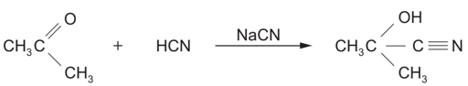
(i) Draw the mechanism for this reaction. Name the type of reaction mechanism occurring.
(iii) In a further experiment an excess of hydrogen cyanide reacted with 17.4 g of propanone (Mr 58.06) to produce 18.6 g of 2-hydroxy-2-methylpropanenitrile (Mr 85.07).
Calculate the percentage yield of 2-hydroxy-2-methylpropanenitrile.
(iv) The dehydration of 2-hydroxy-2-methylpropanenitrile produces 2-methylpropenenitrile, H₂C=C(CH₃)CN. This compound can undergo addition polymerisation giving poly(2-methylpropenenitrile). Write the formula of the repeating section of this polymer.
(c) State one difference between condensation polymerisation and addition polymerisation.
19. 2016 Old Unit 2 Qn. 10c
Arachidonic acid is an unsaturated fatty acid containing more than one double bond.
Bromine water is used to confirm that the fatty acid is unsaturated, with sufficient bromine used to react with all the double bonds.
(i) Give the colour change expected in this chemical test.
(ii) The product of the reaction of arachidonic acid with excess bromine contains 25.44% carbon, 3.39% oxygen and 67.75% bromine by mass with the remainder being hydrogen.
I. Calculate the empirical formula of this compound.
II. State the number of C=C double bonds present in a molecule of arachidonic acid. Explain how you reached your conclusion.
20. 2017 Unit 2 Qn. 8a (a) Compound X is a hydrocarbon that contains 85.6% of carbon by mass. The relative molecular mass is in the range 50-60.
11.2 g of compound X decolourised exactly 32.0 g of bromine in the absence of light. Further bromine was decolourised when the reaction mixture was placed in direct sunlight.
(i) Find the empirical formula of X and hence its molecular formula. Show clearly how you carried out your calculation.
(ii) Explain what can be deduced from the fact that 11.2 g of X reacts with exactly 32.0 g of bromine.
(iii) What type of reaction mechanism occurs when X reacts with bromine in the absence of light?
(v) Draw the displayed formulae of the following.
I. Compound X
II. The product formed when X reacts with bromine in the absence of light.
21. 2015 Unit 4 Qn. 4. An organic chemist suggested the following method for producing compound M from cinnamaldehyde.
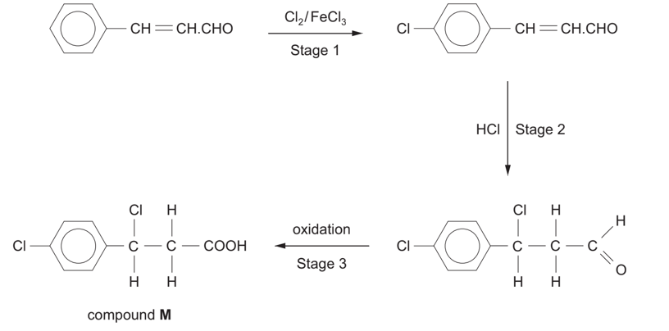
(i) Suggest two reasons why the reaction of cinnamaldehyde with chlorine is unlikely to give only the compound shown and give the displayed formula of another possible product.
(ii) Give the displayed formula of another product that may be formed when hydrogen chloride is added across the double bond in the second stage, explaining why this can occur.
(iv) Explain why compound M, made in this way from cinnamaldehyde, has no effect on the plane of polarised light.
22. 2014 Unit 4 Qn. 2c. 3-Hydroxybutanoic acid is a white solid that can react as a carboxylic acid and an alcohol. 3-Hydroxybutanoic acid readily undergoes elimination reactions to form a mixture of unsaturated acids.
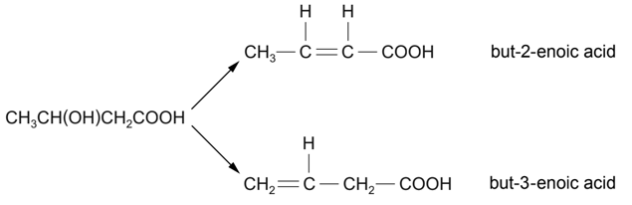
(i) State which of these unsaturated acids exists as E-Z isomers, giving a reason for your answer.
(ii) A scientist reported that the yield of the products was
- But-2-enoic acid 89%
- But-3-enoic acid 4%
- Together with unreacted 3-hydroxybutanoic acid 7%
State any additional information that another scientist would have to know so that the experiment could be repeated to confirm these yields.

