ACID-BASE WORKSHEET

Acids and Bases 1. Foundation
1. Which of the following is not a strong acid in aqueous solution?
(A) HF (B) HCl (C) HBr (D) HI (E) HNO₃
2. Which of the following statements about strong acids is TRUE?
(A) All strong acids have H atoms bonded to oxygen atoms.
(B) For the same initial concentrations, strong acids produce solutions with a higher pH than do weak acids.
(C) The conjugate base of a strong acid is a strong base.
(D) Strong acids are very concentrated acids
(E) None of these is true
3. What is the pH of a 0.0015 M solution of HNO₃?
4. Consider 2 solutions of HCl . One solution has a pH of 3.0, and the other has a pH of 5.0. As compared with the pH 3.0 solution, the pH 5.0 solution has:
(A) 100 times more [H⁺] (B) 100 times less [H⁺]
(C) 3 times more [H⁺] (D) 3 times less [H⁺]

5. HNO₂(aq), nitrous acid, has K_{a} = 4.5 x 10⁻⁴. What is the best description of the species present in a 0.1 M solution of nitrous acid?
(A) Equal amounts of HNO₂(aq), H⁺(aq) and NO₂⁻(aq)
(B) Slightly more HNO₂(aq) than H⁺(aq) and NO₂⁻(aq)
(C) Slightly less HNO₂(aq) than H⁺(aq) and NO₂⁻(aq)
(D) Much more HNO₂(aq) than H⁺(aq) and NO₂⁻(aq)
(E) Much less HNO₂(aq) than H⁺(aq) and NO₂⁻(aq)

6. Given the following pK_{a} values, which is the strongest acid of those listed?
HNO₂ (pK_{a} = 3.37)
HF (pK_{a} = 3.45)
HIO₃(pK_{a} = 0.77)
HBrO (pK_{a} = 8.69)
HCN (pK_{a} = 9.31

Acids and Bases 2. Bronsted Lowry
7. A 0.050 M solution of a weak protic acid (HA) is 47% ionized. What is K_{a} for this acid?
8. The pH of 0.10 M of an unknown acid is 5.0. Calculate the K_{a} of the acid?
9. The K_{a} of HCN is 5.0 x 10⁻¹⁰. What is the pH of 0.050 M HCN?
10. Calculate the pH of a 0.300 M solution of benzoic acid, K_{a} value is 6.50 x 10⁻⁵.
11. Calculate the pH of a 0.020M solution of iodic acid (HIO₃, K_{a} = 0.17).
12. A 0.100 M solution of a weak monoprotic acid, HX, is 3.5% ionized. What is the pH of a 0.500 M solution of HX?
13. Which of the following is not a conjugate acid/base pair
(A) H₂CO₃ and CO₃²⁻ (B) H₂PO₄⁻ and HPO₄²⁻ (C) HCl and Cl⁻
(D) SO₄²⁻ and HSO₄⁻ (E) H₂O and H₃O⁺

14. Which of the following pairs of substances are not conjugates?

(A) NH₃ and NH₂⁻ (B) HSO₄⁻ and SO₄²⁻ (C) HCl and H⁺
(D) HSO₄⁻ and H₂SO₄ (E) HO⁻ and H₂O

15. An acid, HA, has a K_{a} value = 1.0 × 10⁻¹. At equilibrium, a solution of this acid is found to have a concentration, [HA]_{eq} = 0.1 M. If the concentration of the conjugate base is 10 M, what is the pH of the solution?

Acids and Bases 3. Uniqueness of Water
16. Calculate the concentration of hydroxide ions in an acidic solution with pH of 4.47.
17. Calculate the concentration of an aqueous Ba(OH)₂ that has pH = 11.50
18. What is the pH of a solution of 1 × 10⁻⁹ M NaOH?
(A) 9 (B) 5 (C) slightly less than 7 (D) slightly more than 7
19. Given that K_{a}(HCN) = 4.9 x 10⁻¹⁰, calculate the equilibrium constant for the reaction HCN(aq) + OH⁻(aq) ⇌ CN⁻(aq) + H₂O(l)
20. At 37 °C, K_{c} for the reaction, A⁻(aq) + H₂O(l) ⇌ HA(aq) + OH⁻(aq) = 4.0 × 10⁻⁶ . If K_{a} for HA at 37 °C = 8.0 × 10⁻⁹, calculate K_{w} at 37 °C.
21. Consider the reaction of vitamin C (ascorbic acid, C₆H₈O₆) as shown:
C₆H₈O₆(aq) ⇌ C₆H₈O₅⁻(aq) + H⁺ . Which of the following would cause the equilibrium to shift to the right at 25 °C?
I. Dissolving more vitamin C II. Addition of NaC₆H₈O₅
III. Lowering the pH IV. Addition of hydroxide
Acids and Bases 4. Conjugates and Ions

22. Given the following acid ionization constants, what is the order of increasing base strength of the conjugate bases?
HClO K_{a} = 3.5 x 10⁻⁸ HClO₂ K_{a} = 1.2 x 10⁻²
HCN K_{a} = 6.2 x 10⁻¹⁰ H₂PO₄⁻ K_{a} = 6.2 x 10⁻⁸

23. Given the following K_{b} values, identify the strongest acid of those given

NH₃ K_{b} = 1.8 x 10⁻⁵ CH₃NH₂ K_{b} = 4.38 x 10⁻⁴
H₂NNH₂ K_{b} = 3.0 x 10⁻⁶ C₆H₅NH₂ K_{b} = 3.8 x 10⁻¹⁰
C₅H₅N K_{b} = 1.7 x 10⁻⁹

(A) C₂H₅NH₃⁺ (B) NH₄⁺ (C) H₂NNH₃⁺
(D) C₆H₅NH₃⁺ (E) C₅H₅NH⁺
24. Using the following values of pK_{b}, select the weakest acid from those listed.
C₅H₅N (pK_{b} = 8.75) N₂H₄ (pK_{b} = 5.77) C₆H₅NH₂ (pK_{b} = 9.37)
NH₃ (pK_{b} = 4.75) C₂H₅NH₂ (pK_{b} = 3.19)

(A) NH₄⁺ (B) CH₃NH₃⁺ (C) H₂NNH₃⁺
(D) C₆H₅NH₃⁺ (E) C₅H₅NH⁺
25. Given the following values of pK, which is the weakest base of those listed?
pK_{b} of NH₃ = 4.75 pK_{a} of HNO₂= 3.37 pK_{b} of C₅H₅NH = 8.75
pK_{a} of HBrO = 8.69 pK_{a} of HClO = 7.53

(A) NH₃ (B) ClO⁻ (C) BrO⁻ (D) C₅H₅N (E) NO₂⁻
26. Assuming that each solution has a concentration of 1.0 M, which answer correctly ranks them in order of increasing pH, from lowest to highest?
(A) HBr < HF < NaCl < NH₃ < NaOH (B) HBr < NH₃ < HF < NaCl < NaOH
(C) NaOH < NH₃ < NaCl < HF < HBr (D) NH₃ < NaCl < HBr < HF < NaOH
(E) NaCl < HBr < HF < NH₃ < NaOH
27. Which of the following solutions is NOT correctly described?
I. 0.10 M aqueous ammonium chloride will be acidic
II. 0.10 moles of lithium nitrate in 1.00 L of water will be acidic
III. 0.10 M aqueous sodium acetate will be basic?

28a. An aqueous solution of sodium acetate is found to be basic. This observation can be explained by what net ionic equation?
b. An aqueous solution of ammonium nitrate is found to be acidic. This observation can be explained by what net ionic equation?
29. Which of the following solutions has the highest pH, given that,
K_{a} of HCN = 5.8 x 10⁻¹⁰
K_{a} of CH₃COOH = 1.8 x 10⁻⁴
(A) 0.10 M CH₃COOH (B) 0.10 M CH₃COOK (C) 0.050 M HCN
(D) 0.10 KBr (E) 0.10 M HCN
30. When 0.10 M solutions of barium acetate, ammonium acetate, and sodium acetate are ranked from least basic to most basic, what is the correct ordering?
31. Which of the following correctly describes the forward direction of a Bronsted-Lowry acid-base reaction that has a K value less than 1.
(A) stronger acid + stronger base ⇌ weaker acid + weaker base
(B) weaker acid + weaker base ⇌ stronger acid + stronger base
(C) stronger acid + weaker base ⇌ weaker acid + stronger base
(D) weaker acid + stronger base ⇌ stronger acid + weaker base

Acids and Bases 5. Titrations
32. The pH vs volume curve when a 100 mL of an acid is titrated with 0.50 M NaOH(aq) is shown below. Which statement is incorrect?
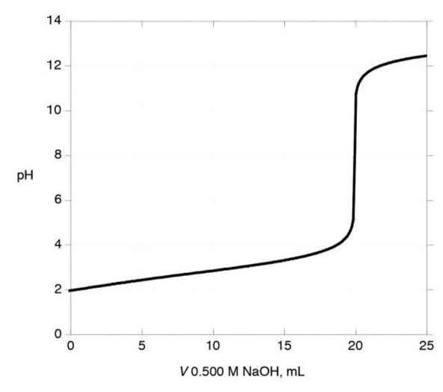
(A) Phenolphthalein would be a suitable indicator for the titration.
(B) The solution after 15 mL has been added is a buffer solution
(C) The pK_{a} of the acid is 4
(D) The initial concentration of the acid is 0.1 M

33. Phenol (C₆H₅OH) has a K_{a} = 1.05 x 10⁻¹⁰. If 100.0 mL of a 0.5000 M aqueous phenol solution is mixed with 100.0 mL of 0.5000 M aqueous sodium hydroxide, the resulting solution will have a pH
(A) = 7 (B) < 7 (C) > 7
34. Determine the pH of a solution in which 40.0 mL of 0.2 M aqueous acetic acid (K_{a} = 1.8 x 10⁻⁵) has been titrated with 20.0 mL of 0.2 M NaOH(aq).
35. The figures show 3 stages in the titration of HOCl (K_{a} = 1.1 x 10⁻⁹) with KOH in aqueous solution. List the solutions in order of increasing pH.
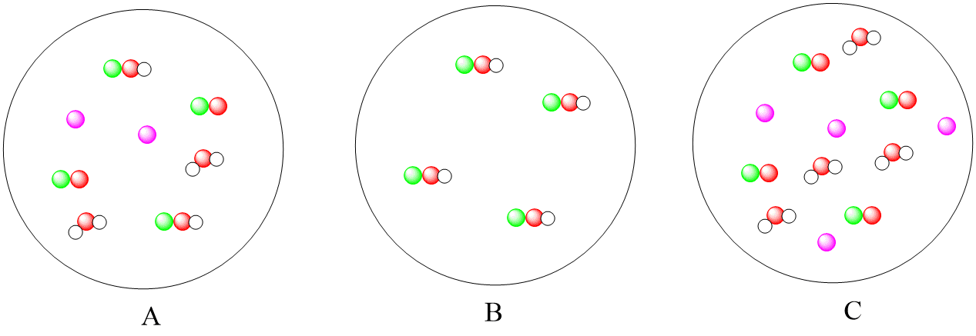
36. Consider the titrations of 250 mL solutions of 0.300 M CH₃COOH and of 0.300 M HCl, both with 0.100 M NaOH. Which of the following would be the same for both titrations?
(A) the initial pH, before any NaOH is added
(B) the pH at the equivalence point
(C) the volume of NaOH added to reach the equivalence point
(D) the pH when exactly 100 mL of NaOH has been added

37. In the titration of a weak monoprotic acid with a solution of sodium hydroxide of known concentration, what quantities are equal at the equivalence point?

(A) The concentrations of hydroxide and hydronium ions
(B) The number of moles of hydroxide ion added and the number of moles of hydronium ion initially present
(C) The volume of sodium hydroxide solution added and the volume of acid solution initially present
(D) The concentration of hydroxide ion added and the concentration of monoprotic acid initially present
(E) The number of moles of hydroxide ion added and the number of moles of monoprotic acid initially present

38. A 50.0 mL sample of a 1.00 M solution of a diprotic acid H₂A (K_{a1} = 1.0 × 10^{–6} and K_{a2} = 1.0 × 10^{–10}) is titrated with 2.00 M NaOH. What is the minimum volume of 2.00 M NaOH needed to reach a pH of 10.00?
39. 20.0 mL of an aqueous solution of ethylamine, CH₃CH₂NH₂, is titrated with 0.300 M aqueous HCl. If the pK_{a} for CH₃CH₂NH₃⁺ = 10.75, which of the following would be a suitable indicator for this titration?
(A) Alizarin yellow R, color change from 10.0 to 12.0
(B) Bromocresol green, color change from 4.0 to 5.6
(C) Thymol blue, color change from 1.2 to 2.8
(D) Phenolphthalein, color change from 8.0 to 10.0
40. During the titration of a weak acid (K_{a} = 1 x 10⁻⁴) with a strong base, one should use an acid-base indicator that changes color in the pH range
(A) 2-4 (B) 5-7 (C) 6-8 (D) 7-10 (E) 10-13

Acids and Bases 6. Buffers
41. Which of the following mixture(s) cannot be a buffer solution?
1. H₂SO₄ and KHSO₄
2. Na₂CO₃ and NaHCO₃
3. NH₄Cl and NaCl
42. Which of the following would make a buffer solution?
(A) 100. mL of 0.1 M HF + 100. mL of 0.1 M HCl
(B) 100. mL of 0.1 M NaF + 150. mL of 0.1 M HCl
(C) 100. mL of 0.1 M HF + 150. mL of 0.1 M NaOH
(D) 100. mL of 0.1 M HF + 100. mL of 0.1 M NaOH
(E) 150. mL of 0.1 M HF + 100. mL of 0.1 M NaOH
43. To prepare a buffer that maintains a pH of 7, which of the following would be the best choice for the acid component of the buffer?
acetic acid (CH₃COOH); K_{a} 1.8 x 10⁻⁵ hypochlorous acid (HClO); K_{a} 2.9 x 10⁻⁸
phenol C₆H₅OH; K_{a} 1.0 x 10⁻¹⁰ benzoic acid C₆H₅COOH: K_{a} 6.3 x 10⁻⁵

44. Calculate the pH of a solution that is 1.00 M HF and 0.40 M KF. K_{a} = 7.24 x 10⁻⁴
45. What is the [H₃O⁺] of the solution made when 1.00 g NH₄Cl(s) [MM = 53.5] is dissolved in 30.0 mL of 3.00 M NH₃(aq) [K_{b} = 1.8 × 10⁻⁵]

